**PROJECT REPORT**

**A NOVEL METHOD FOR**

**HANDWRITTEN DIGIT RECOGNITION**

***submitted by***

***PNT2022TMID19951***

Lakshmanram S - 732219IT035

Subash T - 732219IT054

Suresh S - 732219IT056

Prasad P - 732219IT043

Contents

INTRODUCTION 1

1.1 PROJECT OVERVIEW 1

1.2 PURPOSE 1

LITERATURE SURVEY 2

2.1 EXISTING PROBLEM 2

2.2 REFERENCES 2

2.3 PROBLEM STATEMENT DEFINITION 4

IDEATION AND PROPOSED SOLUTION 4

3.1 EMPATHY MAP CANVAS 4

3.2 IDEATION & BRAINSTORMING 5

3.3 PROPOSED SOLUTION 5

3.4 PROBLEM SOLUTION FIT 6

REQUIREMENT ANALYSIS 7

4.1 FUNCTIONAL REQUIREMENTS 7

4.2 NON FUNCTIONAL REQUIREMENTS 8

PROJECT DESIGN 10

5.1 DATA FLOW DIAGRAM 10

5.2 SOLUTION & TECHNICAL ARCHITECTURE 10

5.3 USER STORIES 11

PROJECT PLANNING AND SCHEDULING 12

6.1 SPRINT PLANNING AND ESTIMATION 12

6.2 SPRINT DELIVERY SCHEDULE 13

CODING & SOLUTIONING 14

TESTING 16

8.1 TEST CASES 16

8.2 USER ACCEPTANCE TESTING 18

8.2.1 DEFECT ANALYSIS 18

8.2.2 TEST CASE ANALYSIS 18

RESULTS 19

9.1 PERFORMANCE METRICS 19

ADVANTAGES & DISADVANTAGES 21

ADVANTAGES 21

DISADVANTAGES 21

CONCLUSION 21

FUTURE SCOPE 22

APPENDIX 22

SOURCE CODE 22

 GITHUB 32

 PROJECT DEMO 32

**CHAPTER 1**

# INTRODUCTION

## 1.1 PROJECT OVERVIEW

Machine learning and deep learning play an important role in computer technology and artificial intelligence. With the use of deep learning and machine learning, human effort can be reduced in recognizing, learning, predictions and in many more areas.

Handwritten Digit Recognition is the ability of computer systems to recognise handwritten digits from various sources, such as images, documents, and so on. This project aims to let users take advantage of machine learning to reduce manual tasks in recognizing

digits.

## 1.2 PURPOSE

Digit recognition systems are capable of recognizing the digits from different sources like emails, bank cheque, papers, images, etc. and in different real-world scenarios for online handwriting recognition on computer tablets or system, recognize number plates of vehicles, processing bank cheque amounts, numeric entries in forms filled up by hand (tax forms) and so on.

**CHAPTER 2**

# LITERATURE SURVEY

## 2.1 EXISTING PROBLEM

The fundamental problem with handwritten digit recognition is that handwritten digits do not always have the same size, width, orientation, and margins since they vary from person to person. Additionally, there would be issues with identifying the numbers because of similarities between numerals like 1 and 7, 5 and 6, 3 and 8, 2 and 5, 2 and 7, etc. Finally, the individuality and variation of each individual's handwriting influence the structure and appearance of the digits.

## 2.2 REFERENCES

**Improved Handwritten Digit Recognition Using Convolutional Neural Networks (CNN) (2020)** This paper's primary goal was to enhance handwritten digit recognition ability. To avoid difficult pre-processing, expensive feature extraction, and a complex ensemble (classifier combination) method of a standard recognition system, they examined different convolutional neural network variations. Their current work makes suggestions on the function of several hyperparameters through thorough evaluation utilizing an MNIST dataset. They also confirmed that optimizing hyper-parameters is crucial for enhancing CNN architecture performance. With the Adam optimizer for the MNIST database, they were able to surpass many previously published results with a recognition rate of 99.89%. Through the trials, it is made abundantly evident how the performance of handwritten digit recognition is affected by the number of convolutional layers in CNN architecture. According to the paper, evolutionary algorithms can be explored for optimizing convolutional filter kernel sizes, CNN learning parameters, and the quantity of layers and learning rates.

**An Efficient And Improved Scheme For Handwritten Digit Recognition Based On Convolutional Neural Network (2019)**

This study uses rectified linear units (ReLU) activation and a convolutional neural network

(CNN) that incorporates the Deeplearning4j (DL4J) architecture to recognize handwritten digits. The proposed CNN framework has all the necessary parameters for a high level of MNIST digit classification accuracy. The system's training takes into account the time factor as well. The system is also tested by altering the number of CNN layers for additional accuracy verification. It is important to note that the CNN architecture consists of two convolutional layers, the first with 32 filters and a 5x5 window size and the second with 64 filters and a 7x7 window size. In comparison to earlier proposed systems, the experimental findings show that the proposed CNN architecture for the MNIST dataset demonstrates great performance in terms of time and accuracy. As a result, handwritten numbers are detected with a recognition rate of 99.89% and high precision (99.21%) in a short amount of time.

**Improved Handwritten Digit Recognition Using Quantum K-Nearest Neighbor Algorithm (2019)**

The KNN classical machine learning technique is used in this research to enable quantum parallel computing and superposition. They used the KNN algorithm with quantum acceleration to enhance handwritten digit recognition. When dealing with more complicated and sizable handwritten digital data sets, their suggested method considerably lowered the computational time complexity of the traditional KNN algorithm. The paper offered a theoretical investigation of how quantum concepts can be applied to machine learning. Finally, they established a fundamental operational concept and procedure for machine learning with quantum acceleration.

**Handwritten Digit Recognition Using Machine And Deep Learning Algorithms (2021)** In this study, they developed three deep and machine learning-based models for handwritten digit recognition using MNIST datasets. To determine which model was the most accurate, they compared them based on their individual properties. Support vector machines are among the simplest classifiers, making them faster than other algorithms and providing the highest training accuracy rate in this situation. However, due to their simplicity, SVMs cannot categorize complicated and ambiguous images as accurately as MLP and CNN algorithms can. In their research, they discovered that CNN produced the most precise outcomes for handwritten digit recognition. This led them to the conclusion that CNN is the most effective solution for all types of prediction issues, including those using picture data. Next, by comparing the execution times of the algorithms, they determined that increasing the number of epochs without changing the configuration of the algorithm is pointless due to the limitation of a certain model, and they discovered that beyond a certain number of epochs, the model begins overfitting the dataset and provides biased predictions.

## 2.3 PROBLEM STATEMENT DEFINITION

For years, the traffic department has been combating traffic law violators. These offenders endanger not only their own lives, but also the lives of other individuals. Punishing these offenders is critical to ensuring that others do not become like them. Identification of these offenders is next to impossible because it is impossible for the average individual to write down the license plate of a reckless driver. Therefore, the goal of this project is to help the traffic department identify these offenders and reduce traffic violations as a result.

**CHAPTER 3**

# IDEATION AND PROPOSED SOLUTION

## 3.1 EMPATHY MAP CANVAS

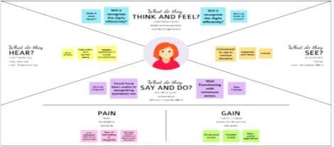

## 3.2 IDEATION & BRAINSTORMING

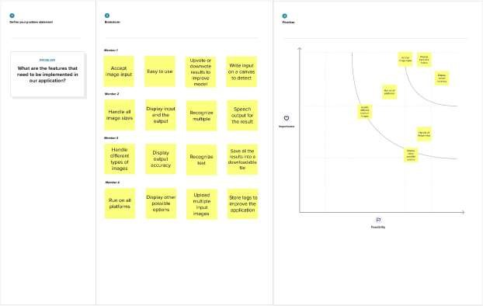

## 3.3 PROPOSED SOLUTION

|  |  |  |
| --- | --- | --- |
| **S.NO** | **PARAMETER** | **DESCRIPTION** |
| 1 | Problem Statement | To create an application that recognizes handwritten digits |
| 2 | Idea / Solution Description | The application takes an image as the input and accurately detects the digits in it. |
| 3 | Novelty / Uniqueness | Instead of recognizing every text, the application accurately recognizes only the digits |
| 4 | Social Impact / Customer Satisfaction | This application reduces the manual tasks that need to be performed. This improves productivity in the workplace. |
| 5 | Business Model | The application can be integrated with  surveillance cameras to  recognize vehicle number plates  The application can be integrated with Postal systems to recognize  the pin codes effectively |
| 6 | Scalability of the Solution | The application can easily be scaled to accept multiple inputs  and process them parallelly to further increase efficiency |

## 3.4 PROBLEM SOLUTION FIT

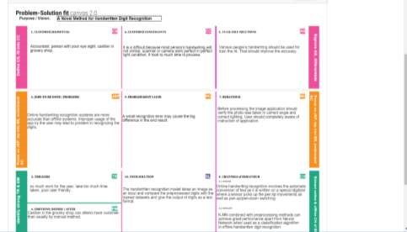

**CHAPTER 4**

# REQUIREMENT ANALYSIS

## 4.1 FUNCTIONAL REQUIREMENTS

|  |  |  |
| --- | --- | --- |
| **FR.NO** | **FUNCTIONAL REQUIREMENTS** | **SUB REQUIREMENTS** |
| FR-1 | Model Creation | Get access the MNIST dataset |
| Analyze the dataset |
| Define a CNN model |
| Train and Test the Model |
| FR-2 | Application Development | Create a website to let the user recognize handwritten digits. |
|  |  | Create a home page to upload images |
| Create a result page to display the results |
| Host the website to let the users use it from anywhere |
| FR-3 | Input Image Upload | Let users upload images of various formats. |
| Let users upload images of various size |
| Prevent users from uploading unsupported image formats |
| Pre-Process the image to use it on the model |
|  |  | Create a database to store all the input images |
| FR-4 | Display Results | Display the result from the model |
| Display input image |
| Display accuracy the result |
| Display other possible predictions with their respective accuracy |

## 4.2 NON FUNCTIONAL REQUIREMENTS

|  |  |  |
| --- | --- | --- |
| **NFR** | **NON-FUNCTIONAL REQUIREMENTS** | **DESCRIPTION** |
| NFR-1 | Usability | The application must be usable in all devices |
| NFR-2 | Security | The application must protect user uploaded image |
| NFR-3 | Reliability | The application must give an accurate result as much as  possible |
| NFR-4 | Performance | The application must be fast and quick to load up |
| NFR-5 | Availability | The application must be available to use all the time |
| NFR-6 | Scalability | The application must scale along with the user base |

**CHAPTER 5**

# PROJECT DESIGN

## 5.1 DATA FLOW DIAGRAM

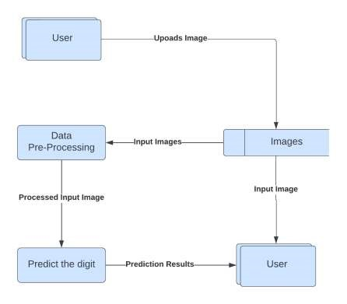

## 5.2 SOLUTION & TECHNICAL ARCHITECTURE

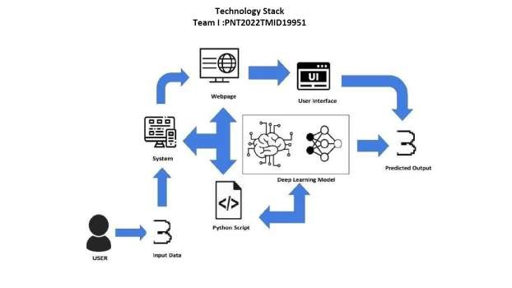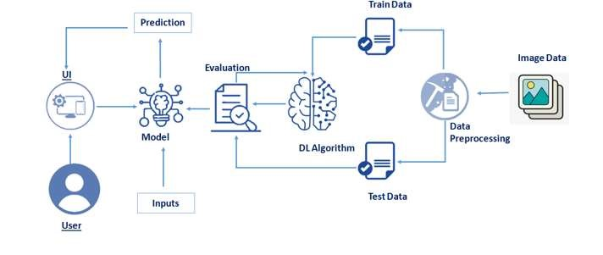

## 5.3 USER STORIES

|  |  |  |  |  |  |  |
| --- | --- | --- | --- | --- | --- | --- |
| User Type | Functional Requirements | User  Story  Number | User Story / Task | Acceptance Criteria | Priority | Release |
| Customer | Accessing the Application | USN-1 | As a user, I should be able to access the  application from  anywhere and use on any devices | User can access the application using the browser on any device | High | Sprint-4 |
|  | Uploading Image | USN-2 | As a user, I should be able to upload images to predict the digits | User can upload images | High | Sprint-3 |
| Viewing the Results | USN-3 | As a user, I should be able to view the results | The result of the prediction is displayed | High | Sprint-3 |
| Viewing Other Prediction | USN-4 | As a user, I should be able to see other close predictions | The accuracy of other values must be displayed | Medium | Sprint-4 |
| Usage  Instruction | USN-5 | As a user, I should have a usage  instruction to know how to use the application | The usage instruction is displayed on the home  page | Medium | Sprint-4 |

**CHAPTER 6**

# PROJECT PLANNING AND SCHEDULING

## 6.1 SPRINT PLANNING AND ESTIMATION

|  |  |  |  |  |
| --- | --- | --- | --- | --- |
| **SPRINT** | **USER STORY / TASK** | **STORY POINTS** | **PRIORITY** | **TEAM MEMBERS** |
| Sprint - I | Get the dataset | 3 | High | mhjg |
| Explore the data | 2 | Medium | Lokesh Raj D Dinesh Kumar E |
| Data Pre-Processing | 3 | High | Nishanth R J Hari Haran S |
| Prepare training and testing data | 3 | High | Nishanth R J Hari Haran S |
| Sprint - II | Create the model | 3 | High | Nishanth R J |
|  | Train the model | 3 | High | Hari Haran S |
| Test the model | 3 | High | Dinesh Kumar E |
| Sprint - III | Improve the model | 2 | Medium | Nishanth R J Hari Haran S |
| Save the model | 3 | High | Lokesh Raj D |
| Build the Home Page | 3 | High | Dinesh Kumar E Lokesh Raj D |
| Setup a database to store input images | 2 | Medium | Nishanth R J |
| Sprint - IV | Build the results page | 3 | High | Dinesh Kumar E Lokesh Raj D |
|  | Integrate the model with the application | 3 | High | Dinesh Kumar E Nishanth R J |
| Test the application | 3 | High | Hari Haran S Dinesh Kumar E |

## 6.2 SPRINT DELIVERY SCHEDULE

|  |  |  |  |  |  |  |
| --- | --- | --- | --- | --- | --- | --- |
| **SPRINT** | **TOTAL**  **STORY**  **POINTS** | **DURATION** | **SPRINT**  **START**  **DATE** | **SPRINT**  **END DATE**  **(PLANNED)** | **STORY**  **POINTS**  **COMPLETED**  **(AS ON**  **PLANNED DATE)** | **SPRINT**  **RELEASE**  **DATE**  **(ACTUAL)** |
| Sprint - I | 11 | 6 Days | 24 Oct 2022 | 29 Oct 2022 | 11 | 29 Oct 2022 |
| Sprint - II | 9 | 6 Days | 31 Oct 2022 | 05 Nov 2022 | 9 | 05 Nov 2022 |
| Sprint - III | 10 | 6 Days | 07 Oct 2022 | 12 Nov 2022 | 10 | 12 Nov 2022 |
| Sprint - IV | 9 | 6 Days | 14 Nov 2022 | 19 Nov 2022 | 9 | 19 Nov 2022 |

**CHAPTER 7**

# CODING & SOLUTIONING

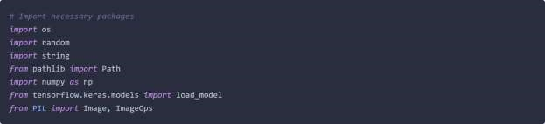

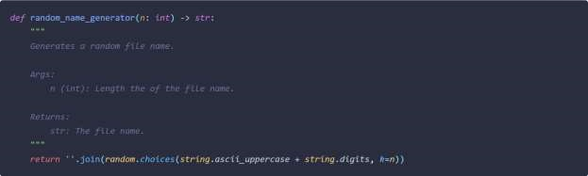

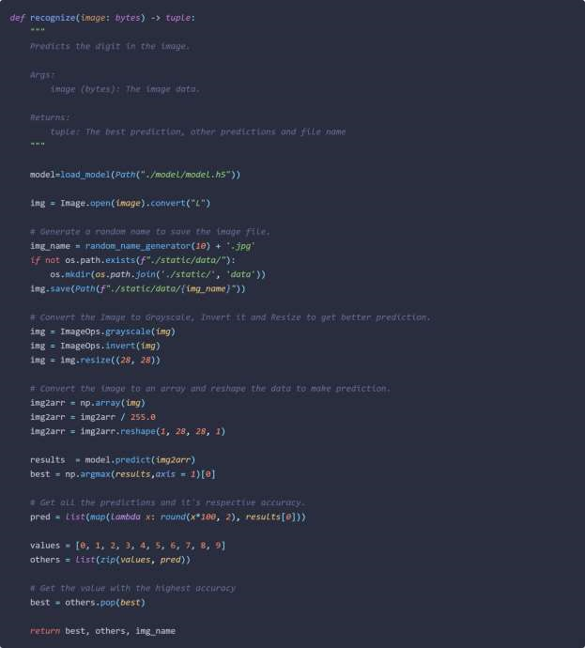

**CHAPTER 8**

# TESTING

## 8.1 TEST CASES

|  |  |  |  |  |  |  |
| --- | --- | --- | --- | --- | --- | --- |
| **Test case ID** | **Feature Type** | **Component** | **Test Scenario** | **Expected Result** | **Actual Result** | **Status** |
| HP_TC_001 | UI | Home Page | Verify UI elements in  the Home  Page | The Home page must be displayed properly | Working as expected | PASS |
| HP_TC_002 | UI | Home Page | Check if the UI elements are displayed properly in  different screen sizes | The Home page must be displayed properly in all sizes | The UI is not displayed properly in screen size  2560 x 1801 and 768 x 630 | FAIL |
| HP_TC_003 | Functional | Home Page | Check if user can upload  their file | The input image should be  uploaded to the application successfully | Working as expected | PASS |
| HP_TC_004 | Functional | Home Page | Check if user cannot upload  unsupported  files | The application should not allow user to select a non image file | User is able to upload any file | FAIL |
| HP_TC_005 | Functional | Home Page | Check if the page redirects to the result page once the input is given | The page should redirect to the results page | Working as expected | PASS |

|  |  |  |  |  |  |  |
| --- | --- | --- | --- | --- | --- | --- |
| BE_TC_001 | Functional | Backend | Check if all the routes are working properly | All the routes should properly work | Working as expected | PASS |
| M_TC_001 | Functional | Model | Check if the model can  handle various image sizes | The model should rescale the image  and predict the results | Working as expected | PASS |
| M_TC_002 | Functional | Model | Check if the model  predicts the digit | The model should predict the  number | Working as expected | PASS |
| M_TC_003 | Functional | Model | Check if the model can handle  complex input image | The model should predict the  number in the complex image | The model fails to identify the digit since the model is not  built to handle such data | FAIL |
| RP_TC_001 | UI | Result Page | Verify UI elements in  the Result  Page | The Result page must be displayed properly | Working as expected | PASS |
| RP_TC_002 | UI | Result Page | Check if the input image is displayed properly | The input image should be  displayed properly | The size of the input image  exceeds the display container | FAIL |
| RP_TC_003 | UI | Result Page | Check if the result is  displayed properly | The result should be displayed properly | Working as expected | PASS |
| RP_TC_004 | UI | Result Page | Check if the other  predictions are displayed properly | The other predictions should be displayed properly | Working as expected | PASS |

## 8.2 USER ACCEPTANCE TESTING

### 8.2.1 DEFECT ANALYSIS

|  |  |  |  |  |  |
| --- | --- | --- | --- | --- | --- |
| Resolution | Severity 1 | Severity 2 | Severity 3 | Severity 4 | Total |
| By Design | 1 | 0 | 1 | 0 | 2 |
| Duplicate | 0 | 0 | 0 | 0 | 0 |
| External | 0 | 0 | 2 | 0 | 2 |
| Fixed | 4 | 1 | 0 | 1 | 6 |
| Not Reproduced | 0 | 0 | 0 | 1 | 1 |
| Skipped | 0 | 0 | 0 | 1 | 1 |
| Won’t Fix | 1 | 0 | 1 | 0 | 2 |
| Total | 6 | 1 | 4 | 3 | 14 |

### 8.2.2 TEST CASE ANALYSIS

|  |  |  |  |  |
| --- | --- | --- | --- | --- |
| Section | Total Cases | Not Tested | Fail | Pass |
| Client Application | 10 | 0 | 3 | 7 |
| Security | 2 | 0 | 1 | 1 |
| Performance | 3 | 0 | 1 | 2 |
| Exception Reporting | 2 | 0 | 0 | 2 |

**CHAPTER 9**

# RESULTS

## 9.1 PERFORMANCE METRICS

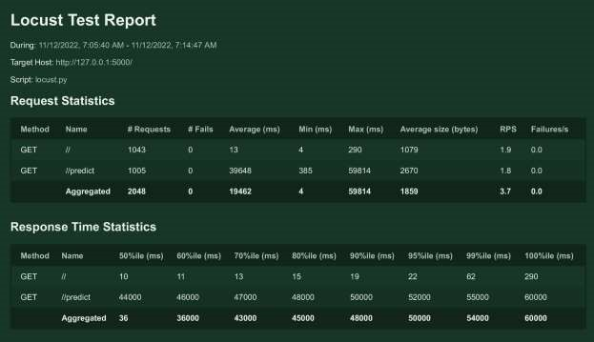

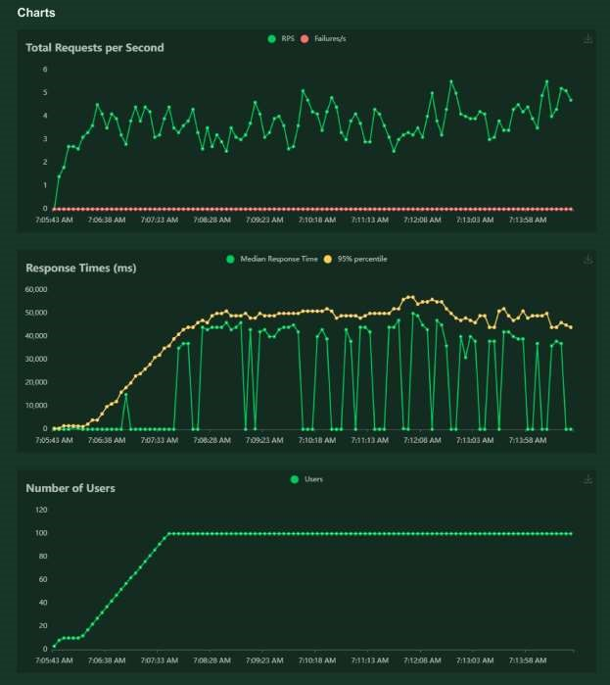

**CHAPTER 10**

# ADVANTAGES & DISADVANTAGES

# ADVANTAGES

* Reduces manual work
* More accurate than average human
* Capable of handling a lot of data
* Can be used anywhere from any device

# DISADVANTAGES

* Cannot handle complex data
* All the data must be in digital format
* Requires a high performance server for faster predictions
* Prone to occasional errors

**CHAPTER 11**

# CONCLUSION

This project demonstrated a web application that uses machine learning to recognise handwritten numbers. Flask, HTML, CSS, JavaScript, and a few other technologies were used to create this project. The model predicts the handwritten digit using a CNN network. During testing, the model achieved a 99.61% recognition rate. The proposed project is scalable and can easily handle a huge number of users.

Since it is a web application, it is compatible with any device that can run a browser. This project is extremely useful in real-world scenarios such as recognizing number plates of vehicles, processing bank cheque amounts, numeric entries in forms filled up by hand (tax forms) and so on. There is so much room for improvement, which can be implemented in subsequent versions.

**CHAPTER 12**

# FUTURE SCOPE

This project is far from complete and there is a lot of room for improvement. Some of the improvements that can be made to this project are as follows:

* Add support to detect from digits multiple images and save the results
* Add support to detect multiple digits
* Improve model to detect digits from complex images
* Add support to different languages to help users from all over the world

This project has endless potential and can always be enhanced to become better. Implementing this concept in the real world will benefit several industries and reduce the workload on many workers, enhancing overall work efficiency.

# APPENDIX

# SOURCE CODE

MODEL CREATION

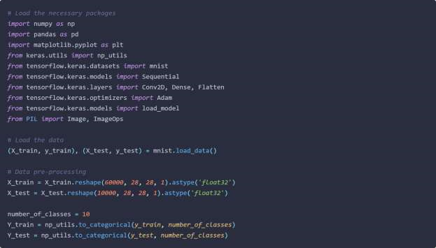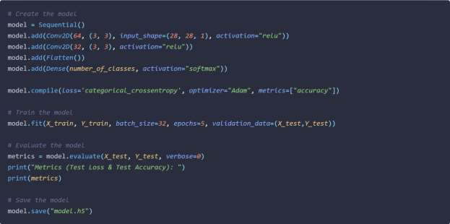

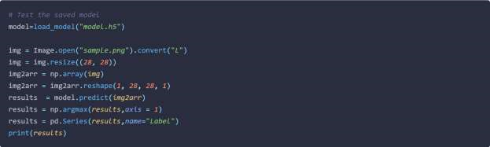

FLASK APP

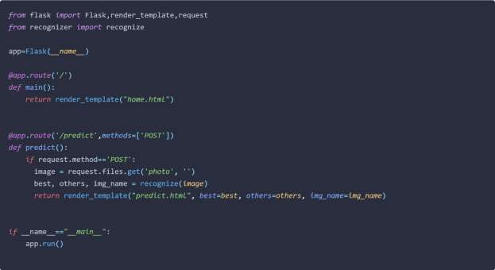

RECOGNIZER







HOME PAGE (HTML)

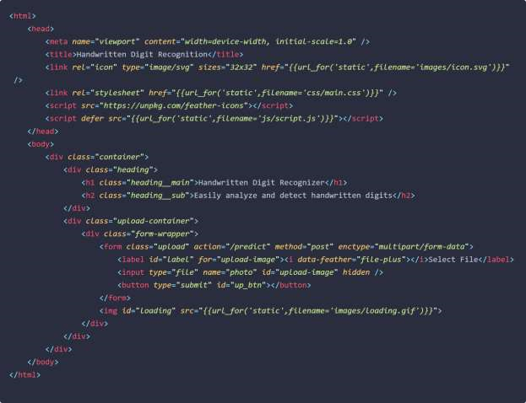

HOME PAGE (CSS)

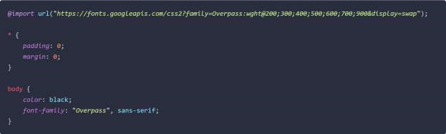

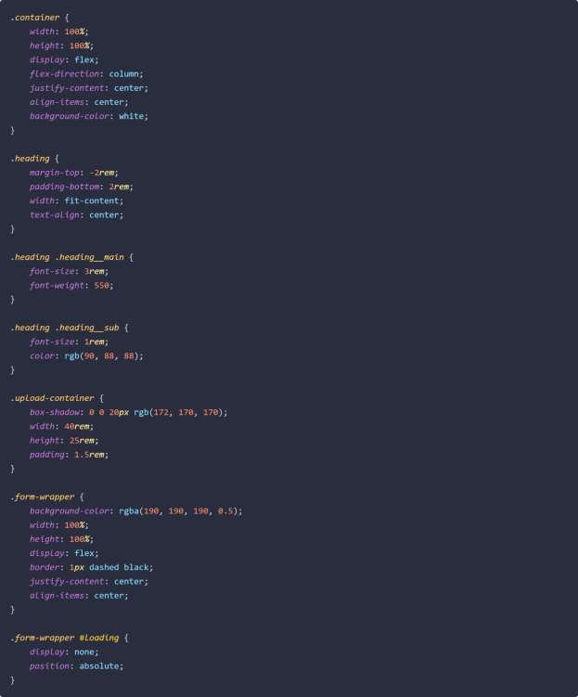

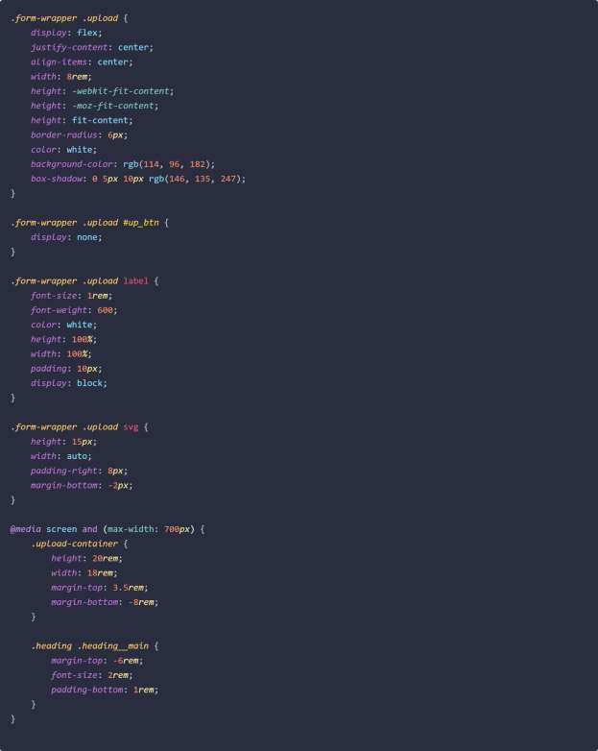

HOME PAGE (JS)



PREDICT PAGE (HTML)

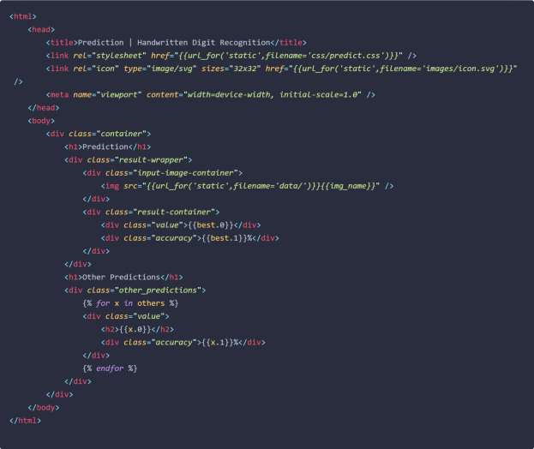

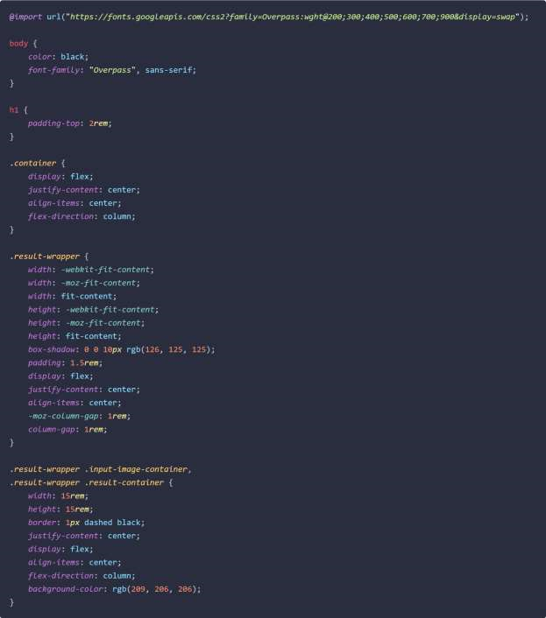

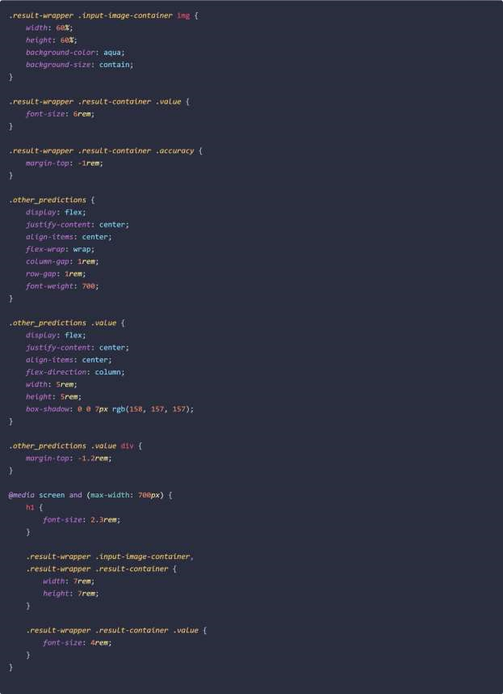

# GITHUB

https://github.com/IBM-EPBL/IBM-Project-33404-1660219873

# PROJECT DEMO

<https://drive.google.com/file/d/1b2O66aiutWbtu5o0J5SzueqNaS14u7Gq/view?usp=share_link>